A Changing Climate: Environmental Assessment for a Proposed Mine in Yukon, Canada.
1.0 Introduction: This paper pertains to the construction, operation, reclamation and closure of the Coffee Gold Mine (Coffee Project or Project), a proposed gold development project in west-central Yukon, approximately 130 kilometres (km) south of Dawson, Yukon, Canada. Major infrastructure related to mining and processing at the Project area includes: an upgraded road; a primary waste rock storage facility; several open pits; water diversion structures and storage ponds; haul roads; primary and secondary crushing facilities; heap leach facilities; a gold refinery; an accommodation complex; and an all-weather airstrip.
Local climate conditions for the site are typical for the region: average annual air temperature (T) is -2.6 °C and mean annual precipitation (P) is estimated to be 485 mm (65% rain, 35% snow) at elevation 1,300 m above sea level. Inspection of the instrumental record from nearest weather stations (e.g., Dawson, Mayo, Pelly Ranch) confirms T and P have been increasing on an annual basis since the 1960s (refer to Figure 1, air temperature trends are shown). Further, climate change scenario data for the Project area indicate continued change for these key water balance variables (i.e., +5°C and +20% increases by 2100) moving forward.
2.0 Objectives of the Poster: Against this changing climate context, engineering and permitting studies are ongoing at the Coffee Gold Mine. This paper summarizes steps taken to create a long-term (84-year), daily- climate record that accounts for a changing climate and then introduces a site-specific water balance model (WBM) that has been constructed and calibrated using GoldSim modelling software. To evaluate potential issues and risks associated with the Project and to fulfill requirements of the environmental assessment process, the 84-year climate record was used to drive the WBM with outputs being used to quantify residual streamflow changes attributable to the Project.
3.0 Generation of a Long-term, Daily- Climate Record for the Project: The procedures below were followed to generate a long-term climate record for the mine site:
- Daily climate data from the mine site (i.e., air temperature, precipitation) and a nearby regional station (McQuesten) were assembled to create monthly predictive relationships (i.e., x-axis, regional station; y-axis, mine site climate station) based on 4-years of overlapping data.
- Next, the regional station (predictor) and the monthly predictive relationships derived for air temperature and precipitation were utilized to compute a long-term synthetic climate record representative of the mine site. The McQuesten, YT, climate station was selected as the most desirable regional predictor station owing to its close proximity to the mine, overall duration (28 years) and active monitoring status through 2015.
- To span the full Project life (i.e., Construction (Today to 2021); Operations (2020 to 2029); Closure (2030 to 2040); and Post-closure (2041 to 2100), the 28-year climate record was looped three times to create an 84-year, daily climate record.
- To represent a plausible future condition, climate change scenario data were downloaded (SNAP, 2016) from the Scenario Network for Alaska and Arctic Planning (SNAP, University of Alaska – Fairbanks), a research collaborative that produces downscaled, historical and projected climate data for sub-Arctic and Arctic regions of Alaska and Canada.
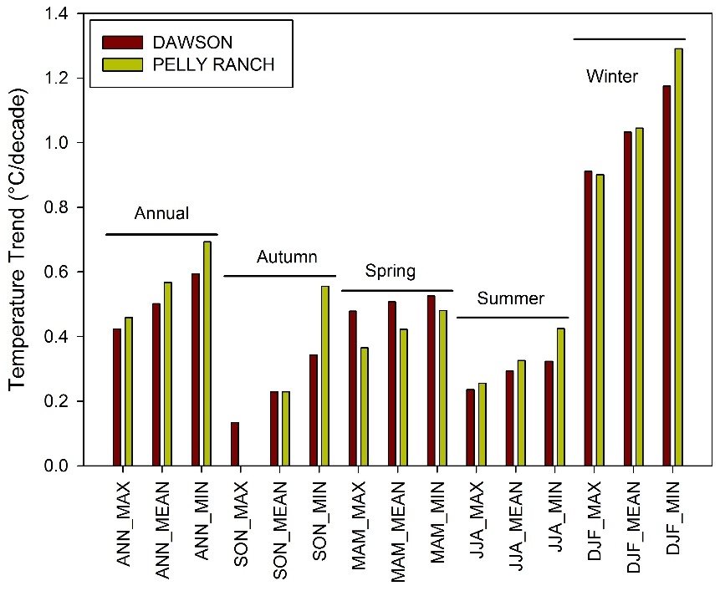
Figure 1: Long-term air temperature trends by season for nearby Dawson A and Pelly Ranch climate stations. The analysis is based on period of record 1955-2013.

- Monthly air temperature and precipitation predictions (2001 to 2100, CMIP3/AR4 – A2 Scenario, 2 km grid) for grid points covering the mine site extent were downloaded, averaged and used to scale 84-year daily climate record. For water balance modelling, the resultant climate-scaled daily weather dataset was utilized to represent years 2018 to 2101 inclusive.
- At monthly time step, assembled climate data are shown in Figure 2.
4.0 Construction of a Site-Wide Water Balance Model for Natural and Base Case Conditions:
The WBM for the Coffee Gold Mine was developed in GoldSim, a flexible, object-oriented software tool for the numerical simulation of complex natural or engineered systems. GoldSim was specifically designed for tracking water movement in groundwater and surface water systems and can also simulate the fate of chemical species within that flow using an integrated contaminant-transport module. In this regard, the software is ideally suited for the Project. The current configuration of the site-wide water balance considers ten receiving environment nodes, each situated downstream of mine drainages containing waste rock and/or open pits.
The WBM was first constructed and calibrated to predict streamflow conditions in local watercourses for a Natural Flow condition (i.e., a baseline scenario that considers no Project). A detailed description of this model is presented in Table 1, which serves as a summary of how geospatial data and baseline/synthetic climate and hydrometric information were used to construct and calibrate the watershed model. Table 1 also summarizes the outputs (i.e., monthly streamflow predictions per node for an 84-year model run; 28 iterations of WBM output are generated) that ultimately may be exported from the WBM.
The same catchment boundaries, climate and hydrology inputs described for the Natural Flow sub-model were used to populate the undisturbed portions of local watersheds in the Base Case sub-model. However, to represent the disturbed condition, year-by-year mine footprints for proposed open pits, a waste rock storage facility, the heap leach facility, soil and ore stockpiles and related Project infrastructure were encoded into the Base Case sub-model. Sediment control ponds and conveyance structures (e.g., drains, interception ditches) envisioned for the Project were also represented in the Base Case model.
The WBM was configured in GoldSim using separate ‘reservoirs’ to track different types of flow, building upon applicable research and modelling of Christophersen and Seip, 1982 and Seip et al., 1985. Briefly, the architecture of the watershed model is predicated on the concept that natural streamflow, or runoff generated from mine footprint areas, is comprised of three types of flow as described by Maidment (1993): 1) quickflow, generated by storm or snowmelt events and often resulting in peak flow events; 2) interflow, derived from near-surface, lateral movement of infiltrated meteoric water through the catchment; and 3) baseflow, the portion of surface discharge derived from groundwater discharge.
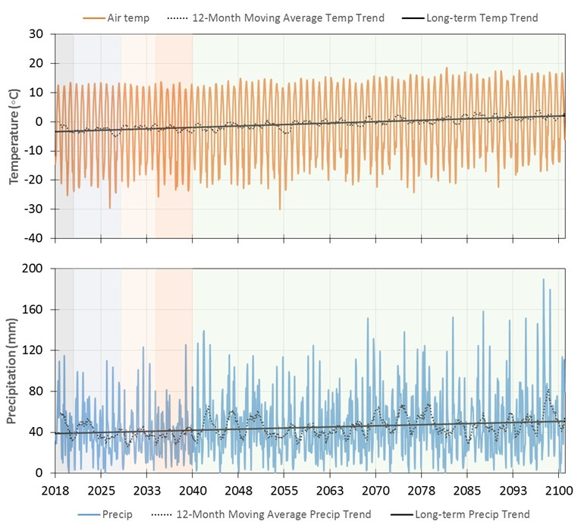
Figure 2: Air temperature and precipitation inputs to the Project water balance model (WBM) for the period 2018 to 2101.
Table 1: Water Balance Model – Natural Flow Sub-model
Natural Flow (Baseline) Sub-model
Catchment Boundaries, Elevation Data | - Watershed boundaries and hypsometric outputs (i.e., curves and representative bands of elevation data) for local catchments were generated from 1:50,000 mapping data.  - To encode elevation dependent climate parameterizations into the WBM, drainages were separated into three elevation bands (400-800 m, 800-1200 m and >1200 m).
Climate | - The natural flow sub-model of the WBM was driven by a 28-year precipitation, air temperature and evaporation record that was looped three times.  - Precipitation and air temperature inputs were scaled by elevation using gradients ascertained from site- and regional climate data.  - Monthly climate change scenario data (from the Scenario Network for Arctic Planning) for the A2 emission scenario (2-km resolution) were used to scale precipitation and air temperature inputs over the long term (Closure and Post-closure phases).
Hydrology | - Baseline hydrology data from autumn 2010 to December 2015 were combined with regional streamflow data to generate long-term synthetic streamflow records.  - The sub-model was calibrated at daily time-step using long-term, daily- synthetic streamflow data as the target.
Outputs | - For this sub-model, 84-year long predicted streamflow records are generated by the WBM. Flow records are produced for seven local tributaries and three large river nodes at a monthly time step.  - The outputs per WBM node consist of 28 unique iterations (i.e., 28-year climate record is time stepped) each extending the 84-year time-period.

The WBM was accurately calibrated to replicate baseline flow conditions for undisturbed areas, or to conditions consistent with professional practices (e.g., targeting a desired waste rock seepage runoff coefficient) in the case of the Base Case module, over a wide range of flow conditions and at high-resolution time-step. Accordingly, surface runoff, snowfall/melt processes and aufeis production from winter baseflow are all represented in the WBM.
Additionally, a 3-D numerical groundwater (GW) model was constructed and calibrated for the Project. The GW model was first calibrated for baseline conditions, then re-run with Project footprints (i.e., main waste rock facility, several open pits) in place to estimate the magnitude of recharge/discharge to/from open pits to deep GW or local creeks. Estimated rates of recharge/discharge were encoded into the WBM for the Base Case sub-model to properly depict the water balance conditions of pit lakes for the closure and post-closure phases of the Project.
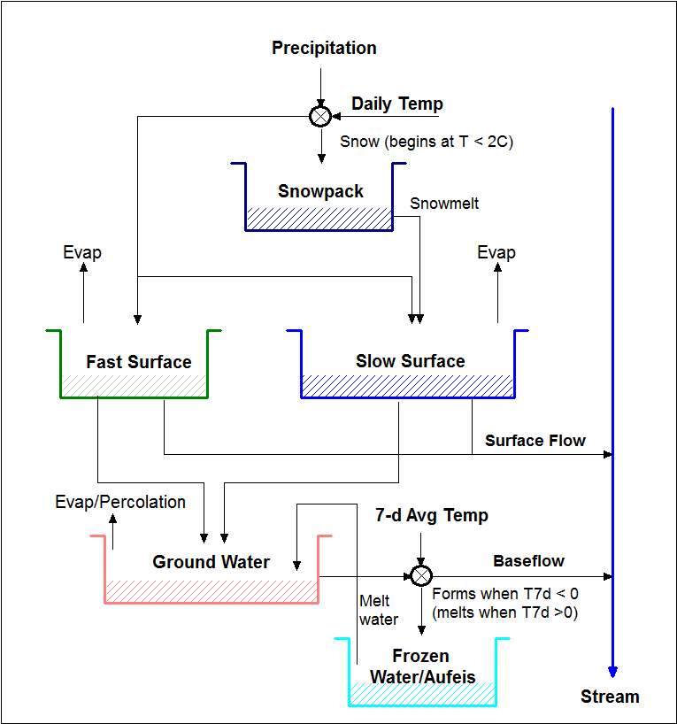
Figure 3: General schematic depicting the three-reservoir watershed model incorporated into the site-wide WBM for the Project.
5.0 Data Analysis and Streamflow Assessment:
For each identified WBM node, GoldSim outputs (i.e., resultant flow series from the Natural Flow and Base Case sub-models) were compared to one another with Project-related flow changes being indexed against natural/baseline conditions. WBM model outputs were averaged to monthly flow values and predicted streamflow changes were represented by a percent change metric as follows:
Percent change (%) = ((Mine Altered Flow – Natural Flow)/Natural Flow) x 100 [Eqn 1]
A suite of streamflow change characteristics (i.e., direction, magnitude, frequency and reversibility of streamflow change) have been proposed to guide a detailed streamflow change assessment. These change characteristics were selected to best quantify and describe potential changes against key components of a natural flow regime as described by Poff et al., 1997.
The intention is to screen WBM outputs and summarize predicted streamflow changes using tabular and graphical formats (e.g., compare Natural Flow vs. Base Case outputs by Project phase using time series or flow duration curve formats) for the four phases of the Project. Identified streamflow changes will then be described in a value component context for the surface hydrology discipline, but the streamflow summary will also inform other water-related studies (e.g., GW, surface water quality, fish and aquatic habitat) to be described as part of the environmental assessment.
References
Christophersen, N. and H.M. Seip. 1982. A model for streamwater chemistry at Birkenes, Norway. Water Resources Research. 18:4, 977-996.
Maidment, D.R. 1993. Handbook of hydrology. McGraw-Hill. 1424 pp.
Poff, N.L., J.D. Allan, M. B. Bain, J.R. Karr, K.L. Prestegaard, B. Richter, R. Sparks, and J. Stromberg. 1997. The natural flow regime: a new paradigm for riverine conservation and restoration. BioScience 47:769-784.
Seip, H.M., R. Seip, R., P.J. Dillon, and E. de Grosbois. 1985. Model of sulphate concentration in a small stream in the Harp Lake catchment, Ontario. Can. J. Fish Aquat. Sci. 42: 927-937.
SNAP, 2016. Scenario Network for Alaska and Arctic Planning. Data portal for climate change scenario data: https://www.snap.uaf.edu/tools/data-downloads

